1. Start the application.

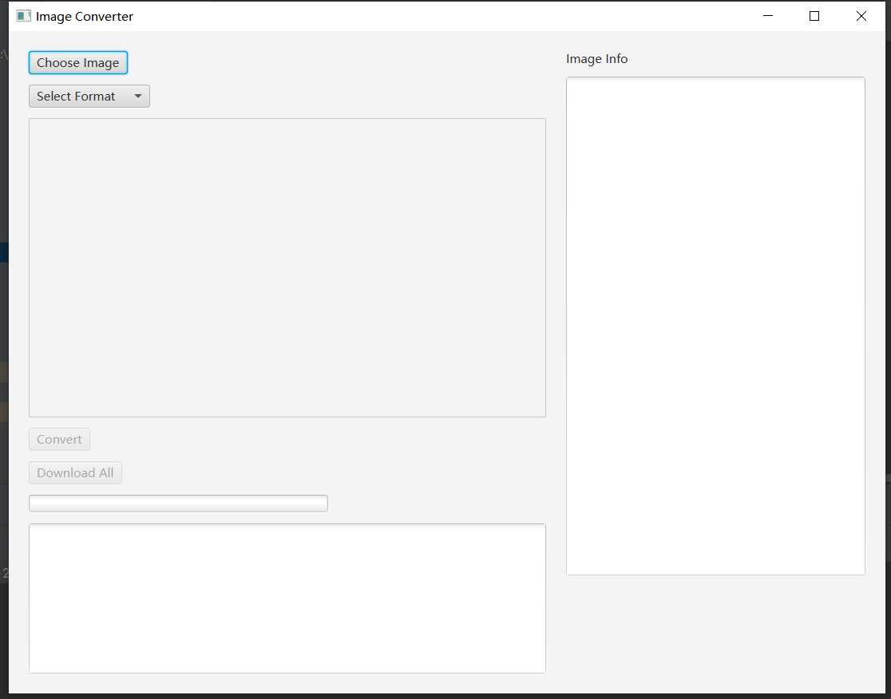

1. Click the “Choose Image” button, open file chooser.

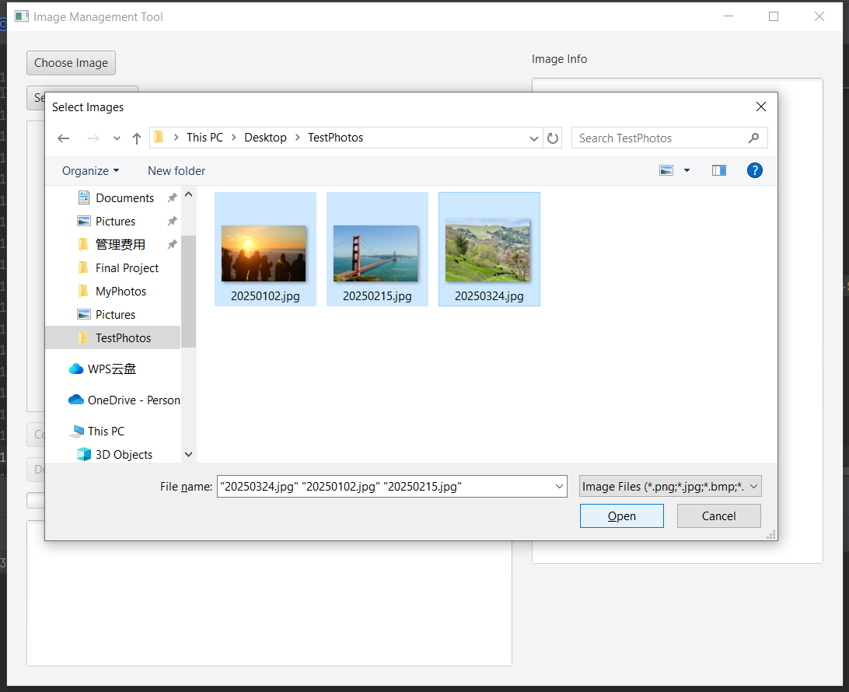

1. Select one or more images. The thumbnails would be shown.

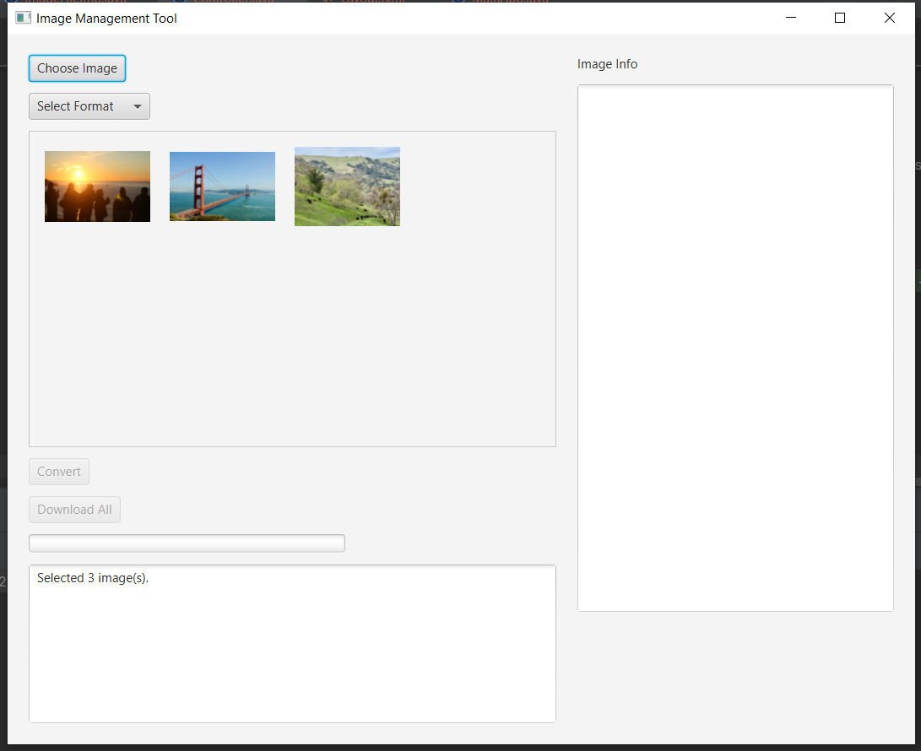

1. Click the shown thumbnail to show the properties of image at the right side.

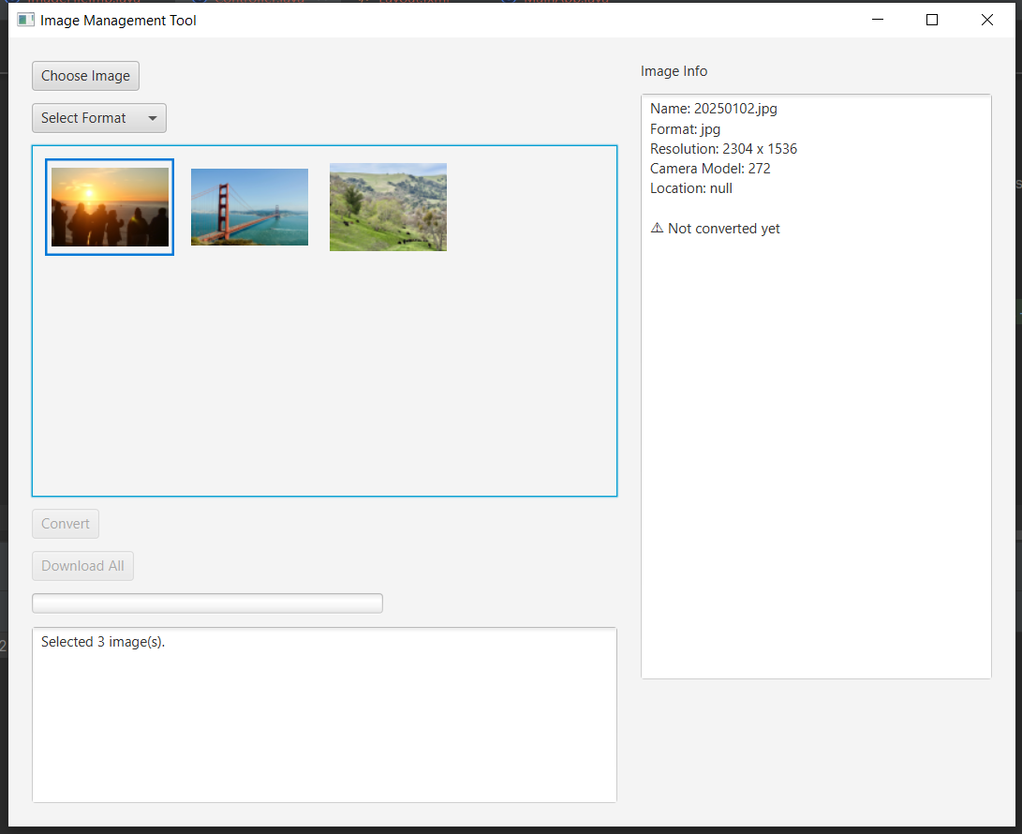

1. Click the “Select format” combo box to select the target format.

It is noticed that “Convert” and “Download” buttons are disabled before the target format is selected.

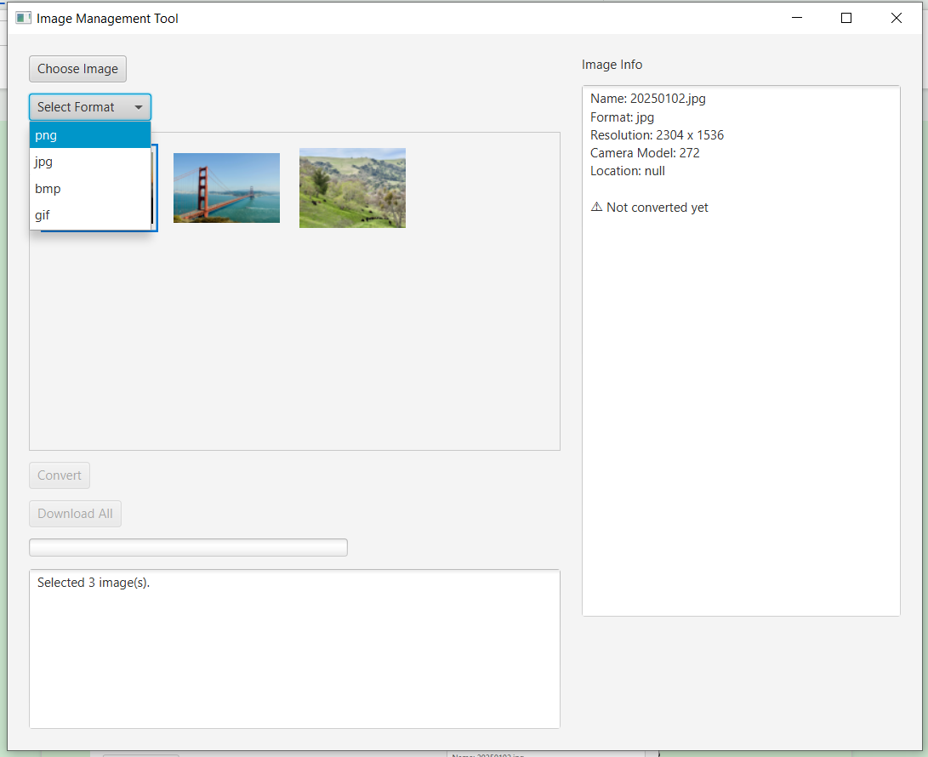

1. Click the “Convert” button to execute conversion.

During the process of conversion, Process would be shown at the process bar, and “Converting...” text would be shown at the bottom text area.

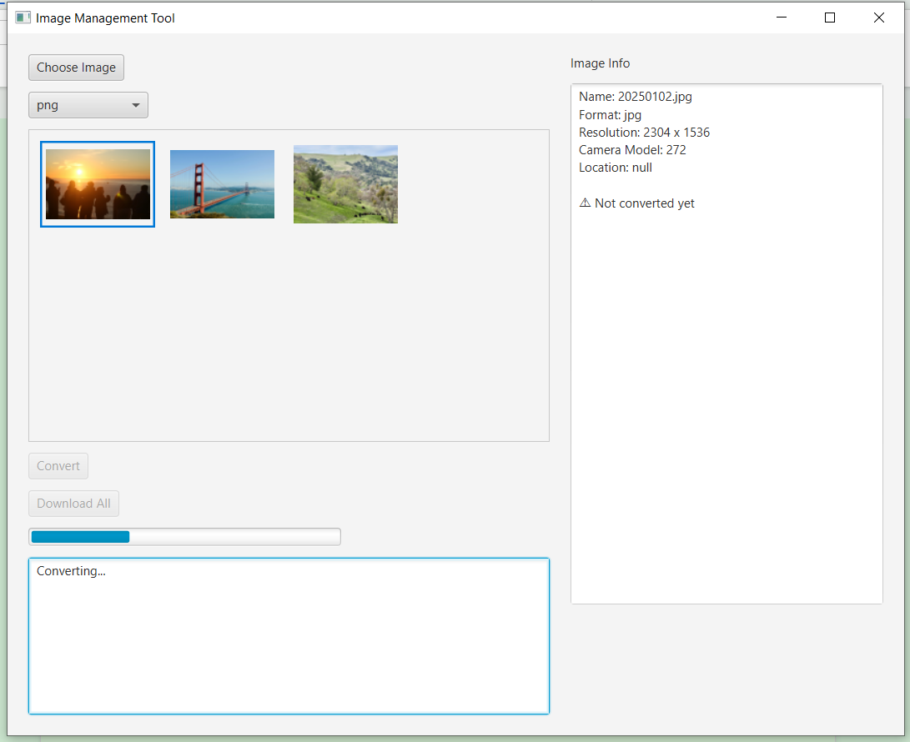

When conversion completed, “Conversion completed.” text would be shown at the bottom text area.

And “Convert” and “Download” buttons are re-enabled.

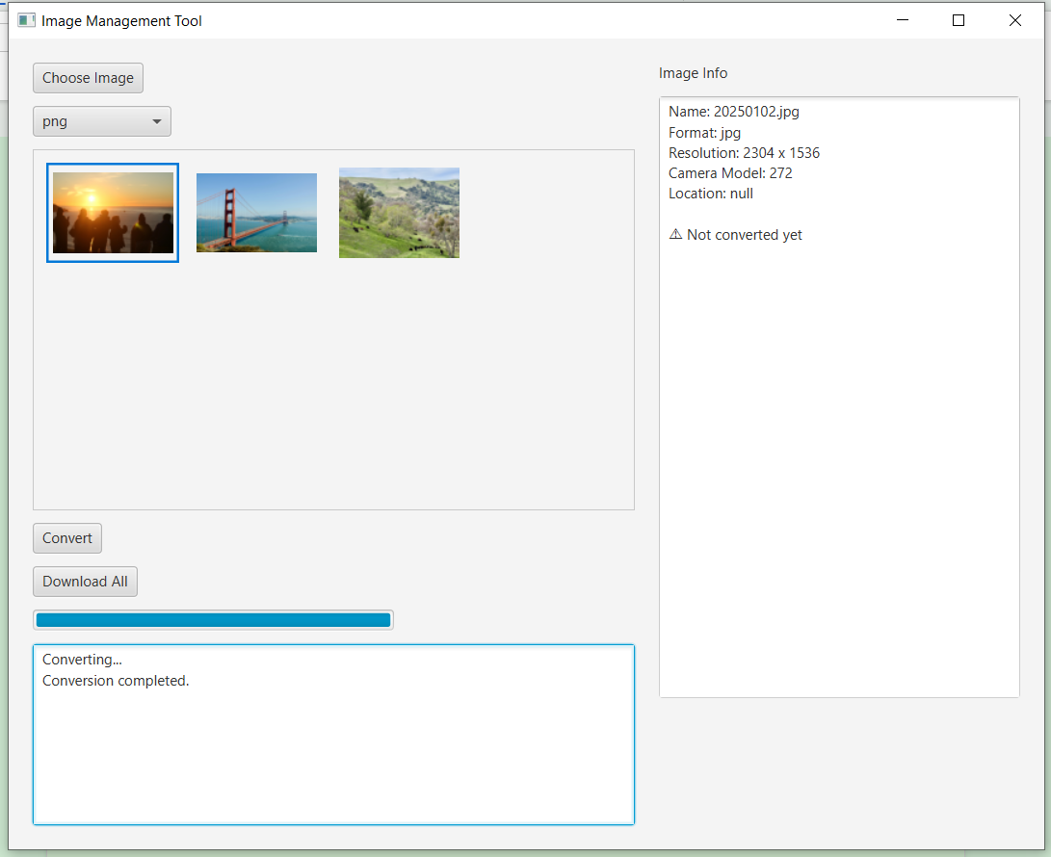

1. Click “Download All” button, open the file chooser to select a save folder, and execute downloading the converted images.

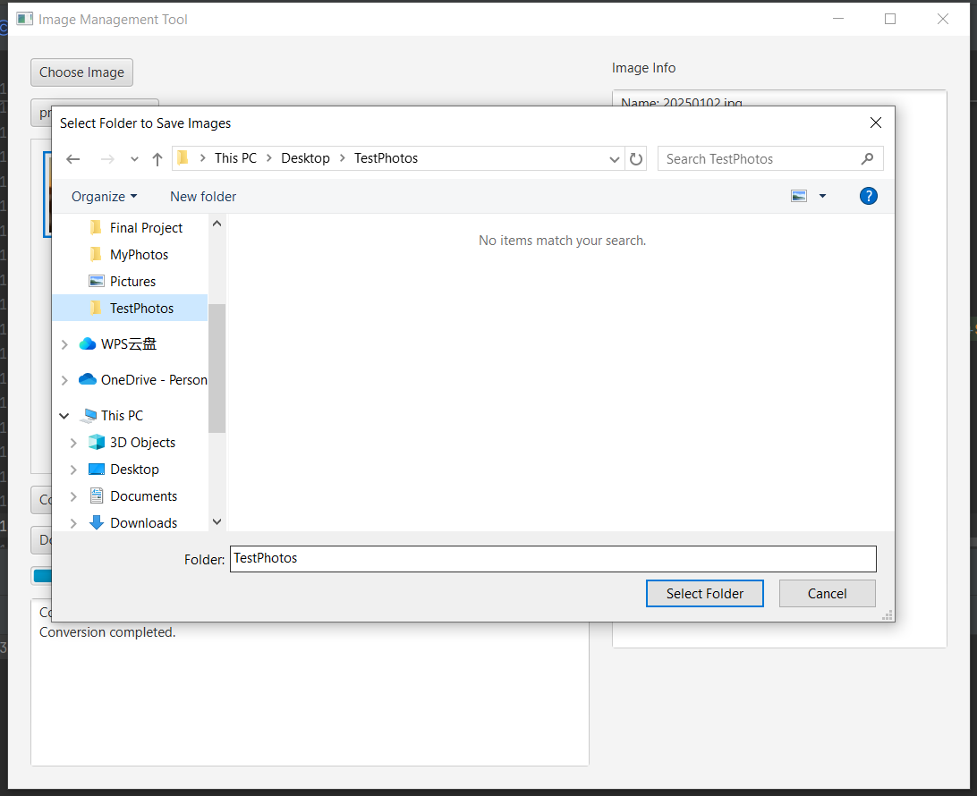

When download completed, “All images saved to (Path)” would be shown at the bottom text area.

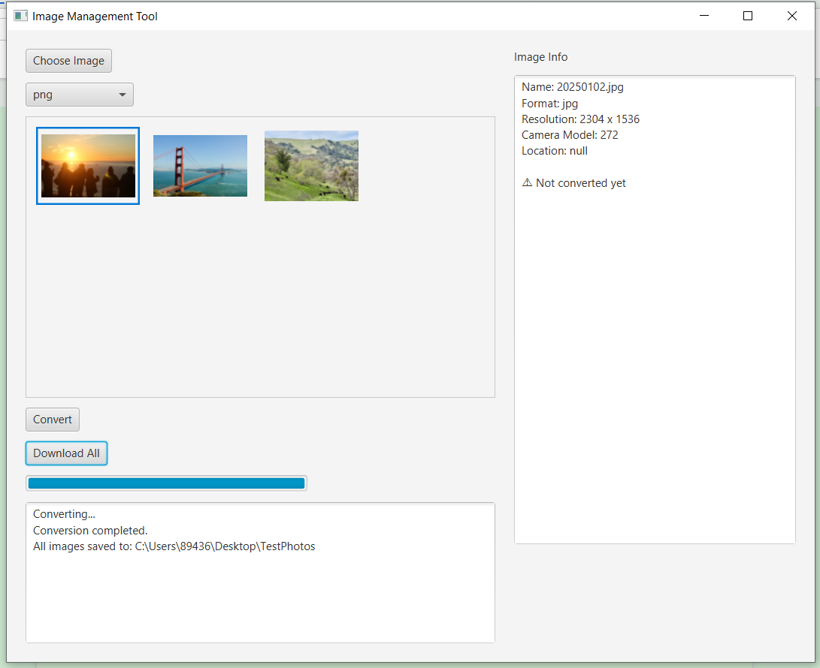

1. Open the save folder, we can notice that the converted images are saved.

